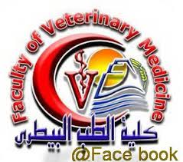 | Beni-suef-university, Faculty of Veterinary Medicine,  Veterinary Animal Care, Use and Teaching Committee (VACUTC)
Approval

Dear/s. Prof. Dr. ……………………………………………………………………………………………

This letter is to inform you that your following animal protocol / Project was approved by
the BSU-VACUTC reviewers.

Approval number:

Title: …………………………………………………………………………………………………………………………………………………………
……………………………………………………………………………………………………………………………………………………………………

Approval Date: / / 2025.

Please be advised that any technical or administrative changes to the approved protocol must be submitted in writing to the BSU-VACUTC for approval. Changes should not be initiated until a written BSU-VACUTC is received. Any adverse events should be reported to the BSU-VACUTC as they occur.

Best Regards
Chairman of - VACUTC Vice Dean of Post-graduate studies and Researches
------------------------- -------------------------
Prof. Mohamed El Bably Prof. Khaled Adly El Nesr

